DOVETAIL OPERATION
Expansion of the jaws into a recess. This function is for bowl and platter turning where the projection (depth) of the wood blank is not too great i.e. up to 100mm (4 inches). Characteristically these items have a parallel wood grain. IT MUST NOT BE USED FOR ANY LONG WORK (OVER 100mm) AS THERE WOULD BE GREAT DANGER OF WOOD TEARING OUT AND DISLODGING FROM CHUCK.

Instructions below apply to the standard 50mm jaws but the general technique is the same with other accessory jaws. However the maximum size of wood blank that can be mounted, the maximum turning speed and recess size varies with the different accessory jaws. Consult specific instructions included for each jaw set.

This is a strong holding method, using the standard 50mm jaws bowls up to 310mm (12 inches) in diameter can be turned. DO NOT EXCEED 600RPM WITH THIS OPERATION. OUT OF BALANCE STOCK MUST BE TURNED AT THE SLOWEST SPEED POSSIBLE.

50mm jaws: Any recess can be turned between 50mm (2 inches) and 70mm (23/4” inches) diameter.

Choose the diameter which suits your bowl design. However, bear in mind that best workholding will be achieved around 50mm - keep your recesses between 50mm and 60mm where ever possible. Extra care must be taken while turning with recesses above 60mm. The depth of the dovetail recess can be varied according to the size and mass of the workpiece. The larger bowl blanks or softer woods will require a deeper recess up to the maximum of 6mm (1/4 inch). HOWEVER YOU MUST USE THE MAXIMUM RECESS DEPTH ON ALL RECESSES OVER 64mm (2.5 inches) diameter OR ANY WORK WITH A DIAMETER OVER 150mm (6 inches).

For smaller lids and thin platters (not exceeding 150mm diameter) only a shallow recess of around 3mm (1/8 inch) is necessary. It will be a matter of gaining experience as to what combinations and sizes will suit best.

FORMING RECESS
The jaw dovetail has been designed for use with a standard skew scraper. This chisel will make a
recess to the angle required. FOR SAFETY REASONS WE STRONGLY ADVISE AGAINST USING ANY OTHER TOOL. A profile of this chisel is shown opposite. It is best to work with a tool which is already ground to the correct angle. All that is necessary then is to keep the leading edge of the chisel flat on the wood, moving forward and out to form the recess to the required diameter and depth.
Mount bowl blank on screw as described in previous section. It may be convenient to first mark out with a pencil, a circle on the bowl blank. To mark out the recess diameter with a pencil: hold pencil point to desired radius, supported on the toolrest. Then revolve blank by hand thus creating a pencilled circle. However, as specified above, any recess diameter can be made between 50mm (2 inches) - 75mm (3 inches) (standard 50mm jaws) so exact sizing of the recess is unnecessary.

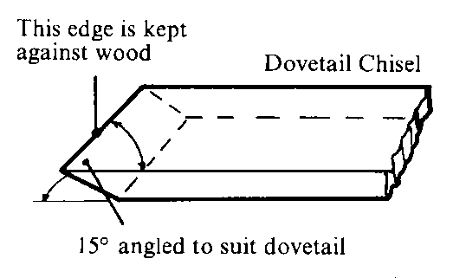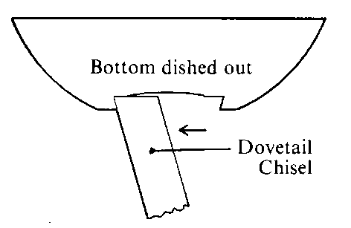

Before scraping out the recess, slightly hollow out the centre of the bowl blank with a bowl gouge
or round nose scraper. The purpose is to relieve the centre so that when the recess is scraped out only half the chisel edge needs to be used. We recommend this to reduce tearing of the wood by scraping action; and to make the recess a little more finished to give a better effect to the overall bowl. Extra embellishments can also be made to the recess to enhance the bowl.

After the recess is finished and the outside of the bowl is turned to shape, wind bowl back off screw.
Bowl blank is now ready to be reversed onto the jaws. Using the lever in the scroll, expand the jaws into the recess. When the jaws are expanded out into the recess, screw the wood blank gently back and forth to make sure it is seated properly on the bottom face of the jaws.

WARNING: MAKE SURE THE JAWS ARE SEATED PROPERLY IN THE RECESS AND THAT THE BOWL IS NOT INCORRECTLY REDING ON THE FLAT SHOULDER SECTION OF THE JAWS BEHIND THE DOVETAIL. THIS COULD LEAD TO THE BOWL DISLODGING FROM THE CHUCK. LOOSEN JAWS AND REMOUNT CORRECTLY

Now give a few gentle raps with the end of a chisel handle or wooden mallet around centre of bowl. Use pinion handle to give an extra nip up. Refer to chuck operation on Page 4. Refer again to safety before operation.

