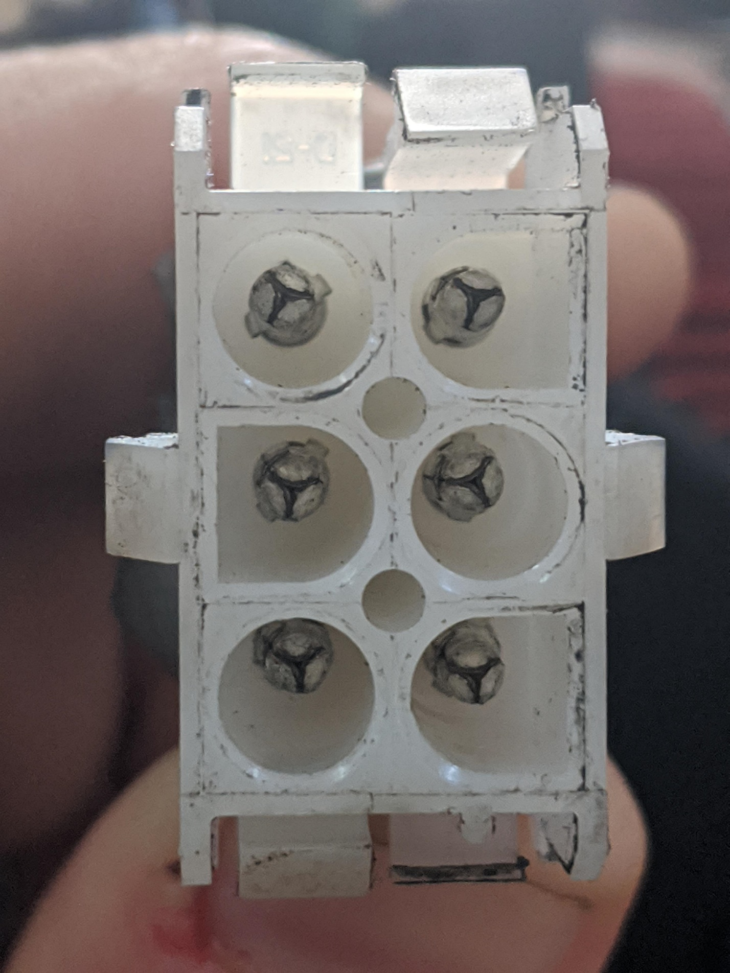

Set multimeter/ohm meter to a range that will show 0 Ω to 20 Ω. Connect a probe between each pin as shown in the image below. Each measurement should read between 10 Ω and 12 Ω, but may vary based on machine and winding configuration.

Flat Side